St Edmund’s C of E Primary School

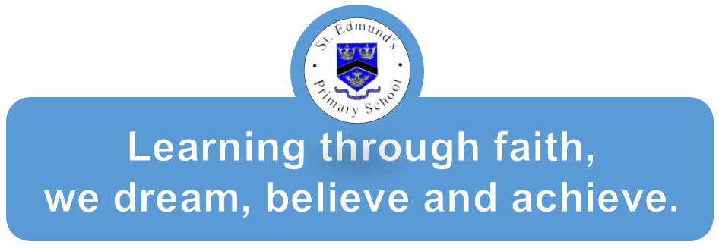

ACCESSIBILTY POLICY

Reviewed: September 2022
Date of Next Review: September 2025

Signed by:
Position:

Introduction
This plan identifies how the school meets the needs of disabled pupils in response to the Special Educational Needs and Disabilities Code of Practice 2014: 0 to 25 years.

Definitions of SEND
‘A child or young person has SEN if they have a learning difficulty or disability which calls for special educational provision to be made for him or her.
A child of compulsory school age or a young person has a learning difficulty or a disability if he or she:
- has significantly greater difficulty in learning than the majority of others of the same age or
- has a disability which prevents or hinders him or her making use of facilities of a kind generally provided for others of the same age in mainstream schools or colleges.’ (SEND code of Practice 2014)

The Accessibility Plan should be read in conjunction with
- The LA admissions policy.
- The School Prospectus.
- The Equality and Diversity Policy.
- The Behaviour Policy.
- The Special Educational Needs policy.
- The School Offer.

The action plan below identifies key activities that will take place to ensure that the school becomes increasingly accessible for pupils with disabilities.

Current Position
- The school building is fully accessible for pupils with physical difficulties.
- The outside play areas are flat and almost completely accessible to wheelchair users
- There is one toilet for disabled pupils.
- The school is well-equipped with a range of learning aids and specific equipment.
- The school supports a range of vulnerable pupils and their families.
- Training has taken place in SEND, ADHD, and dyslexia and there are a high number of trained first aiders.
- SEND is one of the key focuses for development as part of the school’s SIP.
- The school accesses specialist support for Hearing Impairment, Visual Impairment, Physical Disability, Medical Needs and SEND.

Access to Curriculum- Action Plan

Target | Who | Outcomes/Success Criteria | Complete
Learning aids to be produced | SENCO and Class Teachers | Resources from whole school training made and available for use e.g. dyslexia friendly resources and resources for visually impaired pupils | In line with current pupils needs
Intervention training for support staff | SENCO and Class Teachers | Support staff able to work with increased knowledge and provide appropriate resources for pupils | In line with current pupils needs
Termly learning support meetings/PSP reviews to take place to assess and address pupil needs. | SENCO and Class Teachers | Pupil needs reviewed and being addressed. | In line with pupils personal support plans
Training for teachers on differentiating the curriculum for disabled children as required. | SMT and SENCO | Teachers are able to more fully meet the requirements of disabled children’s needs with regards to accessing the curriculum. | In line with current pupils needs
Staff trained to meet individual medical needs of pupils where applicable | SENCO and Class Teachers | Staff completed training for specific needs. | Epi pen training and diabetes awareness training for relevant staff in line with pupil needs

Access to the Physical Environment- Action Plan

Target | Who | Outcomes/Success Criteria | Complete
Ensure each area of the school has wheelchair access and egress. | Headteacher/Site Manage/SENCO | The environment is adapted to the needs of pupils | Yes
Disabled access toilet and Changing facilities in place. | Headteacher/Site Manage/SENCO | A disabled access toilet available at the rear of the school hall and changing facilities in KS1 shared area | Yes
All new internal doors accessible for wheelchair users |  | Newly installed doors closing devices ensure all doors are wheelchair accessible. | Yes
Site is VI friendly | Headteacher/Site Manage/SENCO | Steps and changes in surfaces will be highlighted in neon paint.  Visual alarms installed | No- will be implemented as and when VI pupil attends

Access to Information-Action Plan

Target | Who | Outcomes/Success Criteria | Complete
Understand the needs of pupils and ensure information is available in relevant formats  • Large print  • Braille  • Pictorial or symbolic representations | SENCO and Class Teachers | Pupils have access to curriculum information and all other school information in a format that meets their needs | In line with current pupils needs
re signage is suitable for nonreaders, is clear and well situated | Headteacher/Site Manage/SENCO | Pupils are able to navigate the school regardless of any disability | In line with current pupils needs
The school makes itself aware of the services available for converting written information into alternative formats | SENCO and Class Teachers | Pupils have access to curriculum information and all other school information in a format that meets their needs | In line with current pupils needs

